**Bugs in following images**

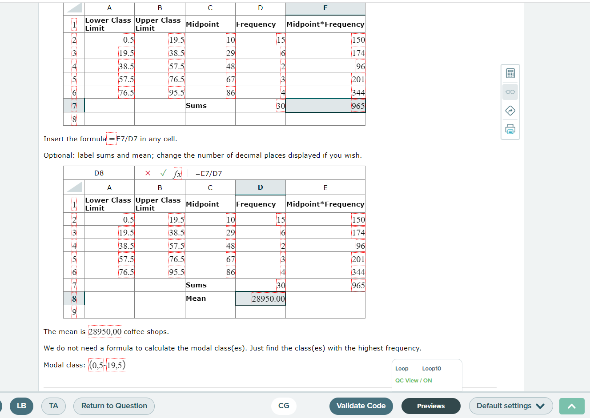

Mean value and modal class contains ‘,’ instead on ‘.’.

Mean of the frequency column is wrong i.e it should be 5.

**Explore the Zeus Learning website and add your observations.**

1. Type the url of zeus learning
2. Explored the website i.e smoke testing.
3. Clicked on various links to test out page reference and scrolling.
4. The Header Section is working fine as expected.



1. In Footer links and mail are working fine and copyright section could be more visible.



**Make a DFD for following user stories:**

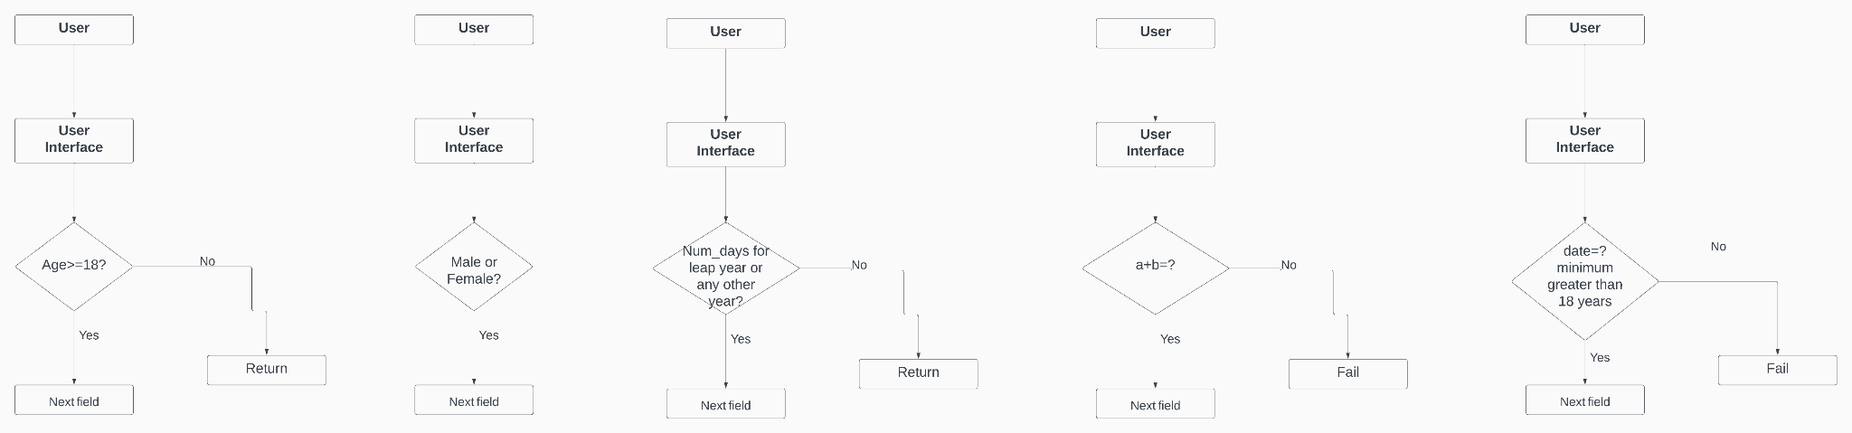

**Find valid, invalid and null data for following**

**1)Name:**

Valid:

Chirag Jha,Chirag,chirag,chirag jha

Invalid:

Chirag7,7chiarg,_chirag,chirag jha jha,

field should not contain any special characters except only space,

NULL:

Empty field

**2) Email address:**

Valid:

[chirag.jha@zeuslearning.com](mailto:chirag.jha@zeuslearning.com),chirag@domainname.com or in,jhachirag7@domain.com

Characters(a-z | A-Z | .) followed by @ symbol

Invalid:

chi@[chi@domain.com](mailto:chi@domain.com)

Character between(a-z | A-Z | .) for email address, any special symbols are not allowed in address.

NULL:

Empty field

**3) Phone Number:**

Valid:

Phone should contain valid country code e.g +91,etc.

And should also contain valid number of digits of phone number based on country.

E.g +91 9123456787.

Invalid:

Values like “91234567897”,912365895.

First value is string and second value has only 9 digits for e.g india there are 10 digit phone number.

NULL:

Empty Field

**4) Day of the Week:**

Valid:

Monday,Tuesday,Wednesday,Thursday,Friday,saturday,sunday.

Invalid:

Mon,Tues,etc and any spelling mistakes.

Null:

Empty Field.

**5) Time:**

Valid:

Check format:HH:MM:SS.

E.g

01:30:49.

Invalid:

25:30:30, 01:61:30, 02:03:61.

NULL:

Empty,00:00:00.